Q1:

Load the two files into the database. Make a screenshot of the graph shows the relation and the nodes.

Note: for node use “MERGE (:Library {id: row.id})”

For relations use

**MATCH** (source:Library {id: row.src})

**MATCH** (destination:Library {id: row.dst})

MERGE (source)-[:DEPENDS_ON]->(destination)

Answer :

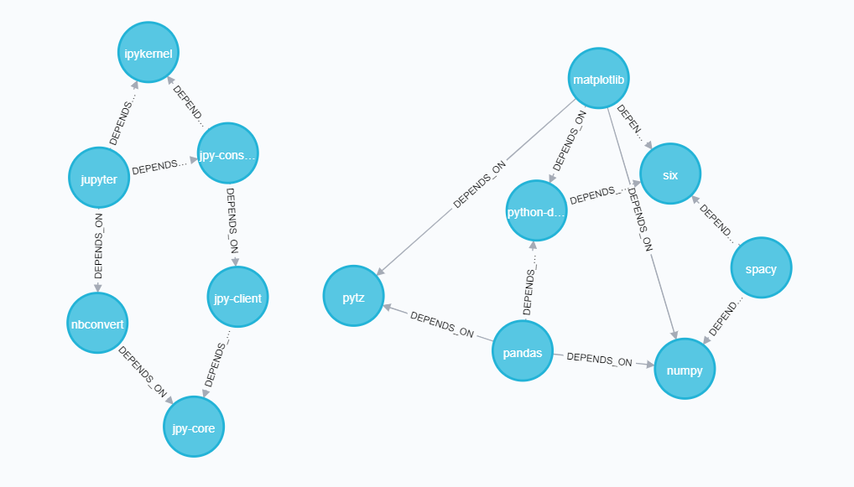

Q2

(Write the query and the answer)

How many nodes in the database?

match (l:Library) return count(l)

16

How many nodes contains “p” in their id?

match (l:Library) where l.id contains "p" return count(l)

13

How many nodes contains “o” and also contains “a” in their id?What are they?

match (l:Library) where l.id contains "o" and l.id contains "a" return l

"python-dateutil", "matplotlib"

How many libraries depends_on “numpy”? what are they?

match (l:Library)-[:DEPENDS_ON]->(l2:Library) where l2.id = "numpy" return l

"pandas","spacy","matplotlib"

Q3

* Start a Trumpworld sandbox and answer:

1. **What are the most connected organizations? List the top5 names.**

"MAR-A-LAGO CLUB, INC",

"THRIVE CAPITAL",

"THE TRUMP ORGANIZATION, INC."

"MERCER FAMILY FOUNDATION"

"40 WALL STREET LLC"

1. **What’s the connection between Donald Trump and Vladimir Putin? List all the names.**

REX TILLERSON, SERGEI MILLIAN

Q4

none